Project Design Phase-II
Technology Stack (Architecture & Stack)

Date | 05 October 2026
Team ID | SWTID-2026-4458
Project Name | Import Data using Transform Maps (Spreadsheet)
Team Leader | Monika B
Team Members | D Keerthana, Chandhana S, Vemalaraju Poojitha, Subasri R
Maximum Marks | 4 Marks

Technical Architecture:
The Deliverable shall include the architectural diagram as below and the information as per the table1 & table 2
Example: Order processing during pandemics for offline mode
Reference: https://developer.ibm.com/patterns/ai-powered-backend-system-for-order-processing-during-pandemics/
Guidelines:
Include all the processes (As an application logic / Technology Block)
Provide infrastructural demarcation (Local / Cloud)
Indicate external interfaces (third party API’s etc.)
Indicate Data Storage components / services
Indicate interface to machine learning models (if applicable)

Our Technical Architecture: Spreadsheet Import using Import Sets & Transform Maps
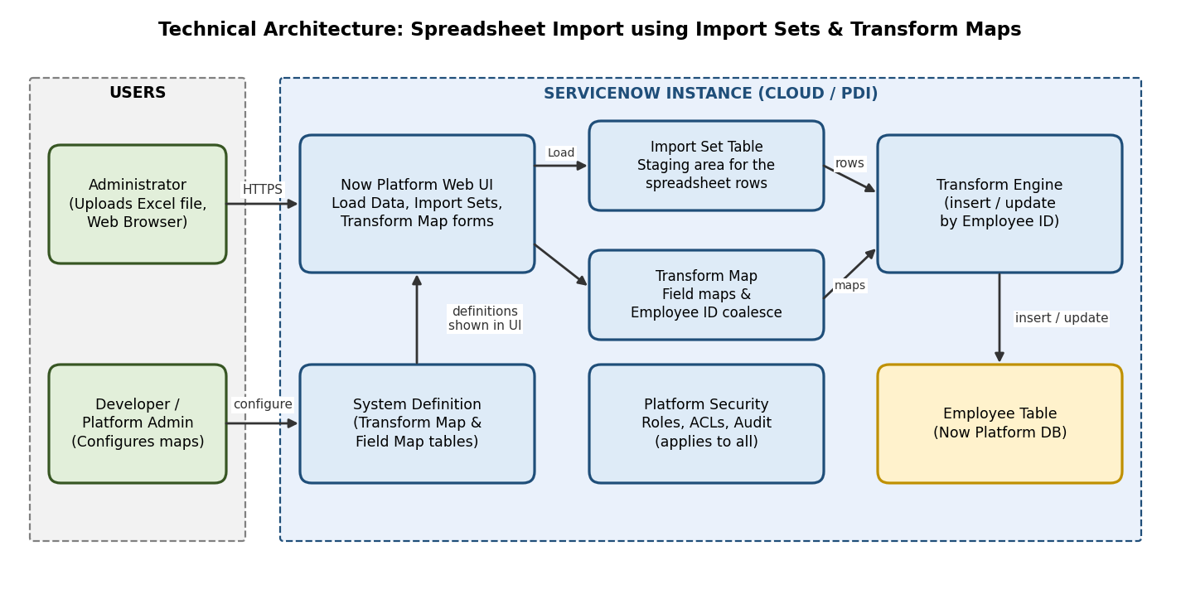

Table-1 : Components & Technologies:
S.No | Component | Description | Technology
 | User Interface | How the administrator works with Load Data, Import Sets and Transform Map forms: ServiceNow web UI in a browser | HTML, CSS, JavaScript (ServiceNow Now Platform UI)
 | Application Logic-1 | Import Set: Load Data uploads the Excel file into an Import Set table (staging area) | ServiceNow Import Sets (Load Data)
 | Application Logic-2 | Transform Map: maps the source fields (Employee ID, Name, Email, Department, Location) to the Employee table fields | ServiceNow Transform Map and Field Maps
 | Application Logic-3 | Coalesce on Employee ID: updates existing employees and inserts new ones when the transform runs | Coalesce field, Transform History
 | Database | Employee records in the target table, the Import Set table and the Transform Map definitions | ServiceNow Now Platform database (Import Set table, sys_transform_map, sys_transform_entry)
 | Cloud Database | Database is managed by the ServiceNow cloud instance | ServiceNow cloud instance (Personal Developer Instance)
 | File Storage | The uploaded Excel spreadsheet is attached to the data source during Load Data | ServiceNow attachment storage (sys_attachment)
 | External API-1 | Not used. Data comes from a spreadsheet upload and all logic runs inside the ServiceNow instance | Not applicable
 | External API-2 | Not used in this project | Not applicable
 | Machine Learning Model | Not used in this project | Not applicable
 | Infrastructure (Server / Cloud) | Application is deployed on a ServiceNow cloud instance. Local server configuration: not needed. Cloud server configuration: ServiceNow PDI; changes moved with Update Sets | ServiceNow Cloud, Update Sets

Table-2: Application Characteristics:
S.No | Characteristics | Description | Technology
 | Open-Source Frameworks | No open-source framework is needed; the solution uses ServiceNow platform features (Import Sets and Transform Maps) | ServiceNow platform tools
 | Security Implementations | Role-based access and ACLs on the Import Set tables, Transform Maps and Employee table; encrypted browser connection; audit of changes | Roles, ACLs, HTTPS/TLS, audit
 | Scalable Architecture | Multi-tier platform (browser, application layer, database). The Transform Map can be reused for future spreadsheets with the same columns, and new fields are added through field maps | ServiceNow multi-tier platform, Transform Maps
 | Availability | Runs on the managed ServiceNow cloud instance, so no extra servers or load balancers are required | ServiceNow cloud platform
 | Performance | Import Sets process rows in bulk. The staging table lets data be checked before it reaches the live table, and field mapping avoids heavy scripts | Import Sets, Transform Maps

References:
https://c4model.com/
https://developer.ibm.com/patterns/online-order-processing-system-during-pandemic/
https://www.ibm.com/cloud/architecture
https://aws.amazon.com/architecture
https://medium.com/the-internal-startup/how-to-draw-useful-technical-architecture-diagrams-2d20c9fda90d

